भारतमौसमविज्ञानविभाग |  | India Meteorological Department
Thursday, 26th June 2025 (5th Ashadha 1947 Saka)
Summary of observations recorded at 0830 hours IST: Southwest monsoon has further advanced over some more parts of Rajasthan, Haryana and Punjab. The Northern Limit of Monsoon passes through 27.0°N/68.5°E, 27.0°N/70.0°E, Jaisalmer, Bikaner, Jhunjhunu, Bharatpur, Rampur, Sonipat, Anup Nagar and 29.0°N/70.0°E. Conditions are favourable for further advance of Southwest monsoon over remaining parts of the country during next 3- 4 days. Under the influence of an upper air cyclonic circulation, a low-pressure area has formed over Northwest Bay of Bengal and adjoining coastal areas of Odisha and West Bengal at 0830 hours IST of today, the 26th June 2025. It is likely to move west-northwestwards across north Odisha and adjoining Gangetic West Bengal, Jharkhand and Chhattisgarh. The trough from northeast Arabian Sea to the cyclonic circulation over northeast Madhya Pradesh ran from northeast Arabian Sea to low pressure area over northwest Bay of Bengal and adjoining coastal areas of Odisha and West Bengal across south Gujarat, Madhya Pradesh, Chhattisgarh & extended between 1.5 & 7.6 km above m. s. l. The upper air cyclonic circulation over central parts of northeast Madhya Pradesh persisted & seen at 0.9 km above m. s. l.
Day temperatures were markedly above normal (> 5.1°C) at isolated places over Odisha. appreciably above normal (3.1°C to 5.0°C) at few places over Arunachal Pradesh; at isolated places over sub Himalayan West Bengal & Sikkim and Tamil Nadu, Puducherry & Karaikal. above normal (1.6°C to 3.0°C) at many places over Jammu-Kashmir-Ladakh-Gilgit-Baltistan-Muzaffarabad; at few places over Assam & Meghalaya, Nagaland, Manipur, Mizoram & Tripura and Lakshadweep; at isolated places over east Uttar Pradesh, Himachal Pradesh, west Rajasthan and Kerala & Mahe. near normal (-1.5°C to 1.5°C) at many places over Andaman & Nicobar Islands, Konkan & Goa, Madhya Maharashtra, Marathwada and Chhattisgarh; at most places over Gangetic West Bengal, Bihar and coastal Karnataka; at few places over Saurashtra & Kutch, Vidarbha, Telangana and Rayalaseema; at isolated places over Jharkhand, west Uttar Pradesh, west Madhya Pradesh, coastal Andhra Pradesh & Yanam and north interior Karnataka. Yesterday, the highest maximum temperature of 42.4°C was reported at Jaisalmer (Rajasthan).
The Southwest Monsoon has been Vigorous over Telangana and active over Odisha, Marathwada, Vidarbha, coastal Andhra Pradesh and Kerala. It has been subdued over Bihar.
Total 338 Station reported rainfall today. Total rainfall is 366.1 cm. Total 325 station reported rainfall today whose normals are available. Total rainfall is 336.9 cm with normal station total is 274.2 cm.

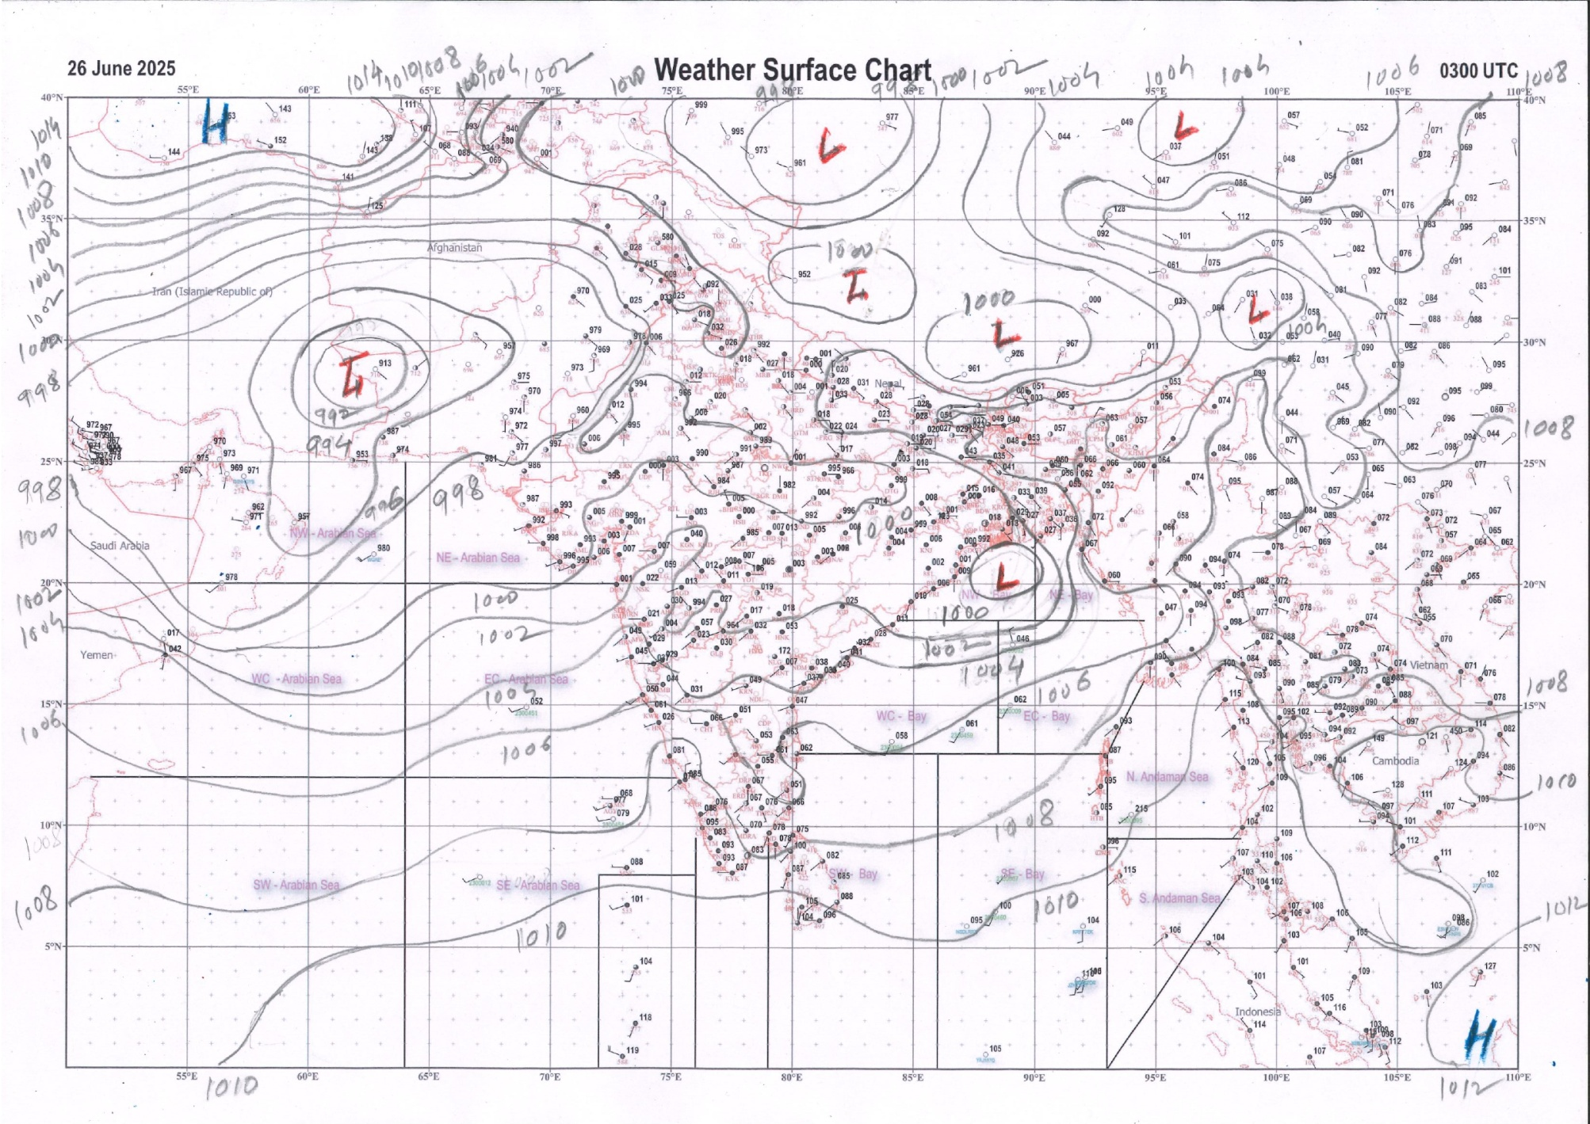 | 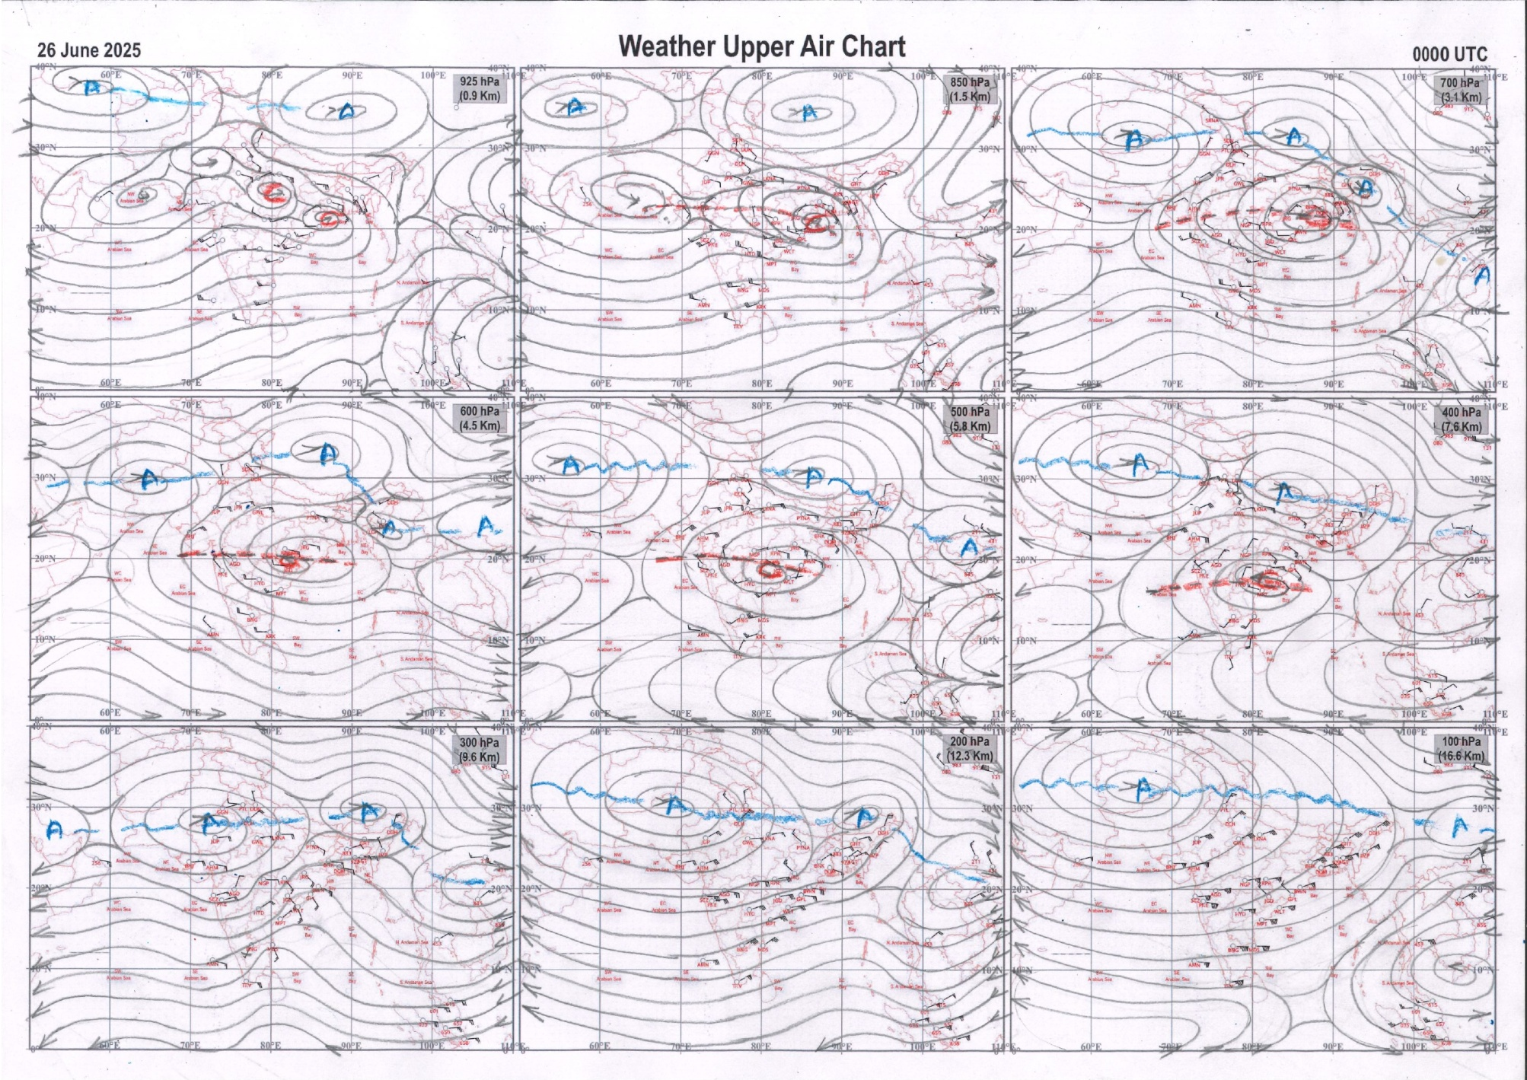
g.1. Analysed surface chart based on 03z observation | Fig.2. Analysed upper air chart based on 00z observation

Dr. S D Sanap.
Scientist ‘D’
CR & S Office, Pune  Issued at 1245 hrs. IST |  | Weather Forecasting Division  CR&S, Pune

Indian regions | Realised rainfall (chief amount in cm during past 24 hrs):
East | most places: Gangetic West Bengal, Odisha+++ and Jharkhand+  many places: Nagaland-Manipur-Mizoram-Tripura  a few places: Sub-Himalayan West Bengal & Sikkim and Bihar  isolated places: Arunachal Pradesh and Assam & Meghalaya+  Patnagarh 17.1, Tikarpara 15.7, Hendigir 7.9, Ramgarh 7.1, Dudhnoi ARG 7.0, Bolangir 6.4, Srijangram ARG 6.3, Mawsynram & Lava 5.6 each, Majitar 5.5, Chottabekra 5.4, Kanchanpur 4.9, Lengpui 4.8, Pakrivarma 4.1, Tadong 4.0, Sangrampur 3.6, Midnapore 2.6, Midnapore (CWC) 2.5, Burdwan PTO 2.4, Ranchi AP 2.3, Tawang AWS 1.5, Bomdila AWS & Muzaffarpur 1.2 each, Bomdila 0.7.
North | most places: Uttarakhand+  many places: Himachal Pradesh+  a few places: west Uttar Pradesh, Punjab+ and east Rajasthan+  isolated places: east Uttar Pradesh, Haryana+, Jammu-Kashmir and Ladakh+++ and west Rajasthan  Katra 14.0, Bhungra SR 11.5, Tibri 9.0, Tajewala 8.5, Jagadhari 8.4, Banbasa 8.1, Danpur 8.0, Reasi ARG & Reasi kvk AWS 7.9 each, Loharkhet 7.8, Palampur 7.7, Banjar 7.5, Deoband 6.4, Banswara SR 6.1, Shahpur kandi & Suratgarh 6.0 each, Anupgarh tehsil SR 5.6, Maudaha 5.3, Dharchula 4.9, Garsana SR 4.1, Dharmsala 4.0, Amritsar 3.1, Karnal 2.6, Najibabad (t) 2.4, Banda 2.0, Azamgarh 1.3, Ghazipur CWC 1.2.
Central | most places: Vidarbha+++ and Chhattisgarh+  many places: west Madhya Pradesh+++ and east Madhya Pradesh+  Malegaon 14.5, Udaigarh 13.2, Ghatanji 13.0, Darri 11.0, Washim 10.8, Neemuch-aws 9.6, Palera 9.0, Ashta-aws & Gharghoda 8.9 each, Mohangarh 8.0, Satna (raghurajnagar) 6.3, Jagdalpur 3.9.
Peninsula | most places: Gujarat Region+++, Konkan & Goa, coastal Karnataka+++ and Kerala#  many places: Marathwada+, coastal Andhra Pradesh, Telangana+++ and south interior Karnataka+++  a few places: Madhya Maharashtra+ and north interior Karnataka+  isolated places: Saurashtra & Kutch, Rayalaseema and Tamil Nadu+++  Lower sholayar AWS 24.1, Dolvan 19.3, Avalanche 18.0, Sholayar 17.5, Nilambur 17.4, Virajpet 16.9, Napoklu 15.7, Umerpada & Dharmasthala 14.0 each, Agumbe emo 13.7, Tamsi 13.5, Valparai PTO 12.8, Talamadugu 12.4, Kochi c.i.a.l. 10.4, Akkalkuwa 9.6, Chandgad 9.3, Valsad & Belthangadi 9.2 each, Adilabad 8.8, Khanapur 7.9, Nanded IMD parttime 7.6, Tondapur ARG 7.1, Billoli 6.9, Londa 6.4, Polavaram 5.4, Tiruvuru 5.3, Canacona 4.6, Visakhapatnam 4.3, Dodamarg 4.2, Honavar 3.6, Mahabaleshwar 3.3, Panjim 1.5, Haveri PTO 1.3, Barvala 1.1, Ranpur & Pulivendla 1.0 each, Srisailam 0.9, Kurnool 0.6, Veraval 0.1.
Islands | many places: Lakshadweep  isolated places: Andaman & Nicobar  Agathi 4.2, Long island & Amini 0.3 each, Minicoy 0.2.
Table 2. Forecast / warnings (distribution of rain / thundershowers) for 7 days (valid from time of origin upto 0830 hrs IST of next day)
Sr N. |  | Sub-division Name | Day 1 | Day 2 | Day 3 | Day 4 | Day 5 | Day 6 | Day 7 | Sr. No. | Sub-division Name | Day 1 | Day 2 | Day 3 | Day 4 | Day 5 | Day 6 | Day 7
 |  |  | 26 Jun | 27 Jun | 28 Jun | 29 Jun | 30 Jun | 01 July | 02 July |  |  | 26 Jun | 27 Jun | 28 Jun | 29 Jun | 30 Jun | 01 July | 02 July
 | 1 | Andaman Nicobar Islands | F  | W  | W | W | F | F | F | 19 | west Madhya Pradesh | W++  | W++ | F+  | F +  | F +  | W++ | W + 
 | 2 | Arunachal Pradesh | S  | S +  | F +  | F + | F ++ | F + | F ++ | 20 | east Madhya Pradesh | W ++  | W +  | W + | W +  | W++ | W++ | W ++ 
 | 3 | Assam-Meghalaya | S  + | F +  + | s +  + | F + | F + | F | F + | 21 | Gujarat region | W ++  | W ++  | W ++  | W ++  | W ++  | W ++ | W ++ 
 | 4 | Nagaland-Manipur-Mizoram-Tripura | F+ + | F + + | S + + | F +  | F +  | F + | F +  | 22 | Saurashtra and Kutch | W ++  | W++ | W++ | W +  | W +  | W + | W + 
 | 5 | Sub Himalayan West Bengal/Sikkim | F | F +  | W +  | W + | W + | W | F + | 23 | Konkan and Goa | W +  | W++ | W + | W++ | W ++ | W++ | W ++ 
 | 6 | Gangetic West Bengal | W+ | W + | W  | W + | W + | W | F + | 24 | Madhya Maharashtra | S + | S ++ | S + | S ++ | S ++ | S ++ | F ++
 | 7 | Odisha | W++ | F + | F +  | S | F + | F + | F + | 25 | Marathwada | F + | S | I | I | I | I | S
 | 8 | Jharkhand | W++ | W + | W + | W++ | W+ | W + | F+ | 26 | Vidarbha | W ++ | F + | S | S | F | F | W
 | 9 | Bihar | S  | F +  | F+  | F + | F + | F | F + | 27 | Chhattisgarh | W +  | W +  | W + | W +  | W +  | W + | F + 
 | 10 | east Uttar Pradesh | I | S  | F +  | W ++ | W++ | W++ | F ++ | 28 | Coastal Andhra Pradesh and Yanam | W +  | F  | S  | I  | I | S | S
 | 11 | west Uttar Pradesh | I | S | F +  | W ++ | W ++ | W ++ | W++ | 29 | Telangana | F +  | S  | I  | I  | I  | I | I 
 | 12 | Uttarakhand | F ++  | W ++  | W ++ | W ++ | W ++ | F +  | F ++  | 30 | Rayalaseema | S  | I  | I | I | I | I | I
 | 13 | Haryana,Chandigarh and Delhi | F +  | S +  | W +  | W++ | W +  | W +  | F +  | 31 | Tamil Nadu, Puducherry and Karaikal | S ++  | S +  | S +  | I | I | I | I
 | 14 | Punjab | W ++  | S  | F +  | W ++ | W +  | W +  | F +  | 32 | Coastal Karnataka | W ++  | W ++ | W + | W | W | W | W
 | 15 | Himachal Pradesh | W +  | W +  | F + | W ++ | W + | W + | F + | 33 | North interior Karnataka | F +  | S +  | S | S | I | I | S
 | 16 | Jammu-Kashmir and Ladakh | W++  | W+  | S+  | S +  | S  | S  | S  | 34 | South interior Karnataka | F #  | S +  | S + | S | I | I | I
 | 17 | west Rajasthan | S +  | F+ | F + | S + | S  | I  | I  | 35 | Kerala and Mahe | W #  | W ++  | W ++ | F + | F | F | F
 | 18 | east Rajasthan | F++  | F++  | F++  | F+  | F+  | S+ | S + | 36 | Lakshadweep | W +  | W  | W | F | F | S | S
Legends: D = Dry I = Isolated S = Scattered F = Fairly widespread W = Widespread #= heavy to very heavy rain at a few places with extremely heavy rain at isolated places +++= heavy rain at a few places with very heavy rain at Isolated places ++= heavy to very heavy rainfall @=Isolated exceptionally heavy rainfall + = heavy rain ●/*= rain or snow ♦ = very light rain ≡=fog= thunderstorm with lightning =Squall / Gusty / gale / strong wind ­ =cold wave/cold day += heat wave/warm night/hot and humid weathe r=Duststorm =ground frost = Hail
Fig. 4: Districtwise warnings for five days for Maharashtra State
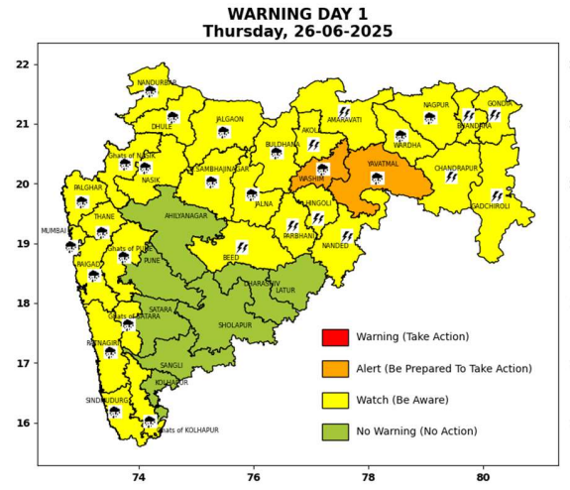 | 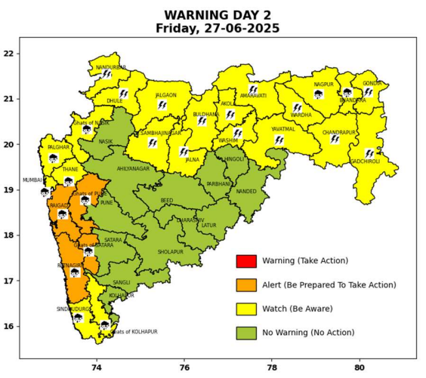 | 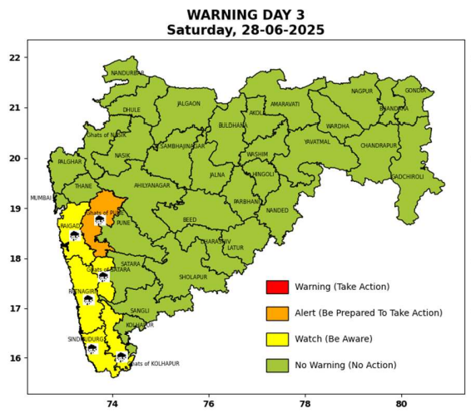 | 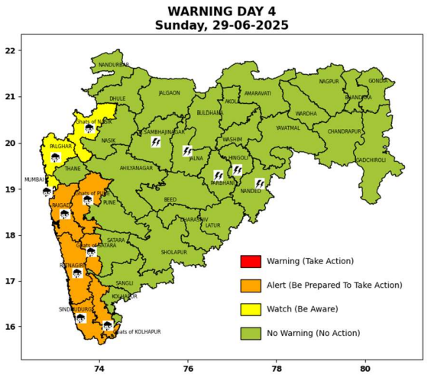 | 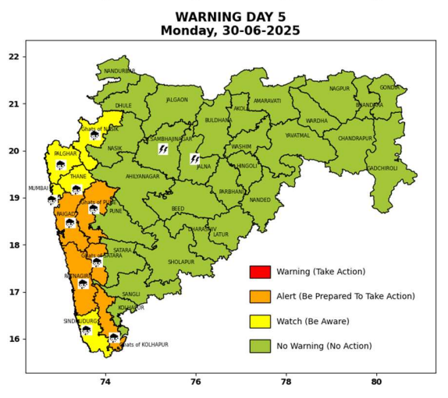

Pune, Lohegaon and Pashan observations at 0830 hrs. IST of Today
 | Temperature (°C) |  |  |  |  | Humidity (%) |  |  |  | Rainfall (mm)
 | Max.  past  24 hrs | Dep.  from  normal | Min.  past  24 hrs. | Dep.  from  normal | Dry  Bulb | At 0830 hrs. IST | Dep.  From  normal | At 1730  hrs. IST of y’day | Dep.  from  normal | Past  24 hrs. | Since  1st June | Dep.  from  normal
PNE | 28.5 | -1.2 | 24.0 | 1.2 | 26.0 | 80 | -1.0 | 72 | -3 | 0.0+ | 260.7 | 131.8
PSN | 27.8 | - | 22.6 | - | 25.4 | 86 | - | 77 | - | 0.2 | 293.5 | -
LHG | 30.6 | -0.4 | 25.6 | 4.6 | 27.8 | 69 | -11 | 61 | -7 | 0.0 | 241.8 | 156.4

 |  |  |  |  |  |  | Local (Pune and neighbourhood) forecast
Max./Min. Temperature (°C) |  |  |  |  |  |  |  |  | Weather
Date | Pune | Pashan | Lohegaon | Chinchwad | Lavale | Magarpatta | NDA | Koregoan Park
26/06/25 | 30 / 24.0* | 29 / 22.6* | 31 / 25.6* | 29 / 24.1* | 27 / 22.9* | 30 / 25.6* | 28 / 24.8* | 29 / 25.5* | Generally cloudy sky. Light rain very likely. (Heavy rainfall at isolated places in ghat areas)
27/06/25 | 31 / 23 | 30 / 22 | 32 / 25 | 29 / 23 | 27 / 22 | 31 / 25 | 29 / 24 | 30 / 25 | Generally cloudy sky. Light rain very likely. (Heavy to very heavy rainfall at isolated places in ghat areas)
28/06/25 | 30 / 23 | 29 / 22 | 31 / 25 | 28 / 23 | 26 / 22 | 31 / 25 | 29 / 24 | 31 / 25 | Generally cloudy sky. Light to moderate rain very likely. (Heavy rainfall at isolated places in ghat areas)
29/06/25 | 30 / 22 | 29 / 21 | 31 / 24 | 28 / 22 | 26 / 21 | 31 / 24 | 28 / 23 | 30 / 24 | Generally cloudy sky. Light to moderate rain very likely. (Heavy to very heavy rainfall at isolated places in ghat areas)
30/06/25 | 29 / 22 | 28 / 21 | 30 / 24 | 29 / 22 | 25 / 21 | 30 / 24 | 28 / 23 | 30 / 24 | Generally cloudy sky. Light to moderate rain likely. (Heavy to very heavy rainfall at isolated places in ghat areas)
01/07/25 | 29 / 21 | 28 / 20 | 30 / 23 | 29 / 21 | 25 / 20 | 30 / 23 | 27 / 22 | 29 / 23 | Generally cloudy sky. Light to moderate rain likely. (Heavy to very heavy rainfall at isolated places in ghat areas)
02/07/25 | 29 / 21 | 28 / 20 | 30 / 23 | 29 / 21 | 25 / 20 | 30 / 23 | 27 / 22 | 29 / 23 | Generally cloudy sky. Light to moderate rain likely. (Heavy rainfall at isolated places in ghat areas)
Rainfall Distribution |  |  | Rainfall Categories | Rainfall (mm) |  | Cloud condition |  |  |  | Rainfall Intensity |  | Range
Widespread (W) | 76-100% |  | Very Light rain | Trace to 2.4 mm |  | Mainly clear sky |  | 1-2 oktas |  | Light Spell |  | 1 cm/hr
 |  |  | Light rain | 2.5 to 15.5 mm |  | Partly cloudy sky |  | 3-4 oktas |  | Moderate Spell |  | 1-2 cm/hr
Fairly Widespread (FW) | 51 – 75% |  | Moderate rain | 15.6 to 64.4 mm |  | Generally cloudy sky |  | 5-7 oktas |  | Intense Spell |  | 2-3 cm/hr
Scattered (S) | 26 – 50% |  | Heavy rain | 64.5 to 115.5 mm |  | Overcast |  | 8 oktas |  | Very Intense Spell |  | 3-5 cm/hr
isolated (I) | 1 – 25% |  | Very heavy rain | 115.6 to 204.4 mm |  |  |  |  |  | Extremely Intense Spell |  | 5-10 cm/hr
D (D) | No Rain |  | Extremely heavy rain | ≥ 204.5 mm |  |  |  |  |  | Cloudburst |  | > 10 cm/hr
Probability Terms in %: |  |  | Heavy snow | 6.5 to 11.5 cms water equivalent of rain
unlikely | < 25 |  | Very heavy snow | 11.6 to 20.4 cms water equivalent of rain
likely | between 25 50
very likely | between 51 75
most likely | >75
* = realized temperature
Mumbai (Colaba) |  |  |  | Nagpur (AP)
Date 2025 | T max °C | T min °C | Weather | T max °C | T min °C | Weather
26/06 | 30 | 25 | Generally cloudy sky with heavy rainfall. | 30 | 24 | Generally cloudy sky with heavy rainfall or thundershowers accompanied with Lightning.
27/06 | 30 | 24 | Generally cloudy sky with heavy rainfall. | 33 | 24 | Generally cloudy sky with a few spells of rain or thundershowers or Thunderstorm accompanied with Lightning.
28/06 | 31 | 25 | Generally cloudy sky with moderate rain. | 34 | 25 | Generally cloudy sky with a few spells of rain or thundershowers.
29/06 | 32 | 25 | Generally cloudy sky with heavy rainfall. | 24 | 26 | Generally cloudy sky with a few spells of rain or thundershowers.
30/06 | 32 | 25 | Generally cloudy sky with heavy rainfall. | 23 | 25 | Generally cloudy sky with a few spells of rain or thundershowers.
01/07 | 31 | 25 | Rain. | 32 | 25 | Generally cloudy sky with possibility of rain or thunderstorm.
02/07 | 31 | 25 | Rain. | 31 | 25 | Generally cloudy sky with possibility of rain or thunderstorm.

